***Syed Muhammad Sarim***

***24k-0718***

***Q8.***

***Understanding data relationship in MS Access:***

***~ Explain Different Types of Relationships:***

*In databases like MS Access, there are three main types of relationships between tables:*

***(a) One-to-One (1:1) Relationship:***

* This type of relationship occurs when each record in Table A relates to one record in Table B, and vice versa.

• Example: Imagine you have a Student table and a Enrollment table where each student can only have one profile.

**Implementation in MS Access**:

* Set the StudentID as the primary key in both tables and create a one-to-one relationship between them.

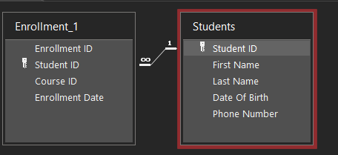

**(b) One-to-Many (1) Relationship:**

* This is the most common type of relationship in databases. It occurs when one record in Table A can relate to multiple records in Table B, but each record in Table B relates to only one record in Table A.
* Example: In the case of *Students* and *Enrollment* tables:
  + One student can enroll in multiple courses (1 relationship between Students and Enrollment).
* Implementation in MS Access:
  + The *StudentID* field in the *Students* table is the primary key, and the *StudentID* in the *Enrollment* table acts as the foreign key.
  + Create this relationship in the Relationships window by dragging the StudentID field from the Students table to the StudentID in the Enrollment table.
  + 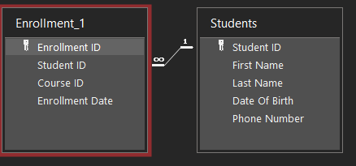

**(c) Many-to-Many (M) Relationship:**

* A many-to-many relationship happens when multiple records in Table A can relate to multiple records in Table B.
* Example: *Students* and *courses* in an educational database: one student can enroll in many courses, and one course can have many students enrolled.
* Implementation in MS Access:
  + MS Access doesn’t directly support many-to-many relationships. You need to create an intermediary (junction) table that breaks this into two one-to-many relationships.
  + Example: A *Students* table and a *Courses* table can have a many-to-many relationship by introducing a third table, *Enrollment*, which stores the *StudentID* and *CourseID* fields.
  + The relationships would be:
    - One-to-Many between Students and Enrollment.
    - One-to-Many between Courses and Enrollment.

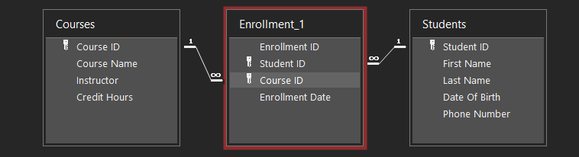

**~ How to Implement Relationships in MS Access**:

* **Step 1:** Open your MS Access database.
* **Step 2:** Go to the Database Tools tab and click Relationships.
* **Step 3:** In the Relationships window, add the tables you want to relate by clicking the Show Table button.
* **Step 4:** Drag and drop the fields you want to relate between tables (e.g., StudentID from Students to Enrollment).
* **Step 5:** In the Edit Relationships dialog that appears, check Enforce Referential Integrity and click Create.

**Example Relationships Setup:**

* One-to-Many: Between Students and Enrollment (through StudentID).
* One-to-Many: Between Courses and Enrollment (through CourseID).
* Many-to-Many: Created using the intermediary Enrollment table between Students and Courses.

**3. Screenshot:**

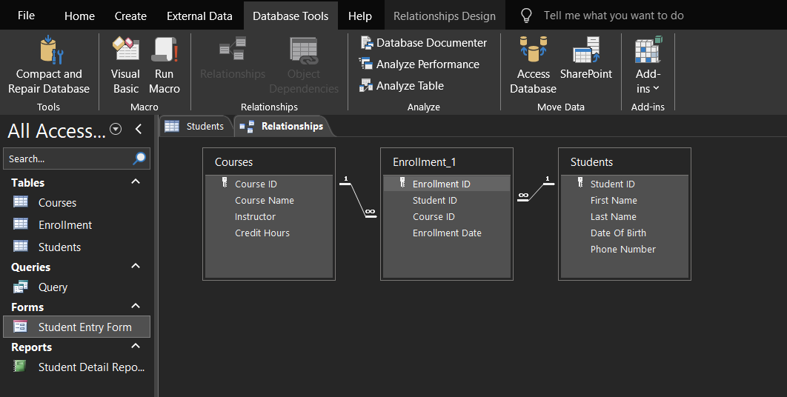



**~ Referential Integrity:**

Referential Integrity is a feature in relational databases that ensures consistency between tables. When enforced:

* You cannot add a record in a related table (like Enrollment) unless it corresponds to an existing record in the primary table (like Students or Courses).
* Cascading updates: If a primary key (e.g., StudentID) in the Students table is updated, all related foreign key records (e.g., StudentID in Enrollment) will automatically be updated to match.
* Cascading deletes: If a record in the Students table is deleted, related records in the Enrollment table are also deleted automatically, preventing orphaned records.

**Importance of Referential Integrity:**

* Maintains Data Accuracy: Prevents orphaned records and ensures that every foreign key reference has a corresponding primary key.
* Improves Data Consistency: Ensures that related data across multiple tables stays synchronized.
* Prevents Invalid Entries: Stops users from accidentally entering records that don't have valid references in related tables**.**